SAVEETHA INSTITUTE OF MEDICAL AND TECHNICAL SCIENCES
DEPARTMENT OF ELECTRONICS AND COMMUNICATION ENGINEERING

SUBJECT NAME: MICROWAVE ENGINEERING
SUBJECT CODE: ECA1308
STUDENT NAME: T. M. Rishika
REGISTRATION NUMBER: 192412200
EXPERIMENT NO 3

EXPERIMENT 3A — DIRECTIONAL COUPLER AND POWER DIVIDER
A. Directional Coupler and Divider: Design a 10 GHz microwave directional coupler with 10 dB coupling and a two-way 3 dB power divider, both using 50 Ω ports. Simulate from 8–12 GHz. At 10 GHz obtain S11, S21, S31 and the isolated-port response. Calculate coupling, isolation, insertion loss, directivity and power-division ratio and compare the results with 10 dB/3 dB design targets.
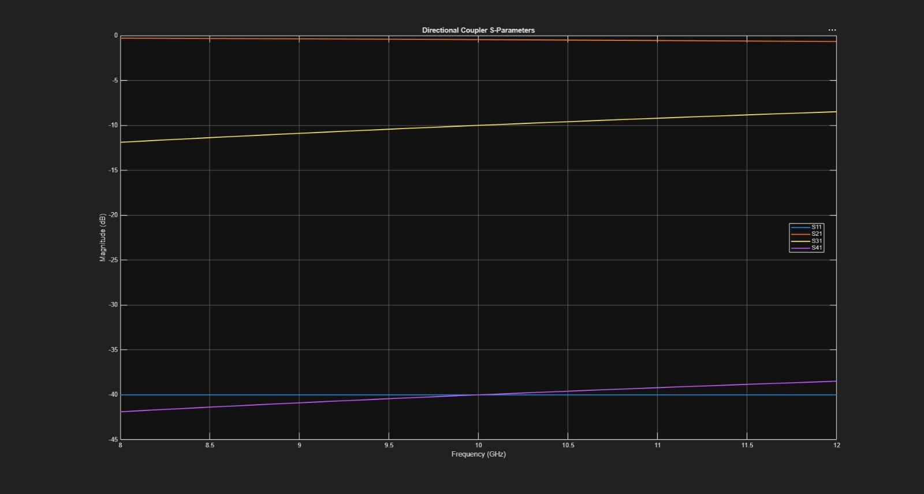
Figure 1. Directional coupler S-parameter response over 8–12 GHz.
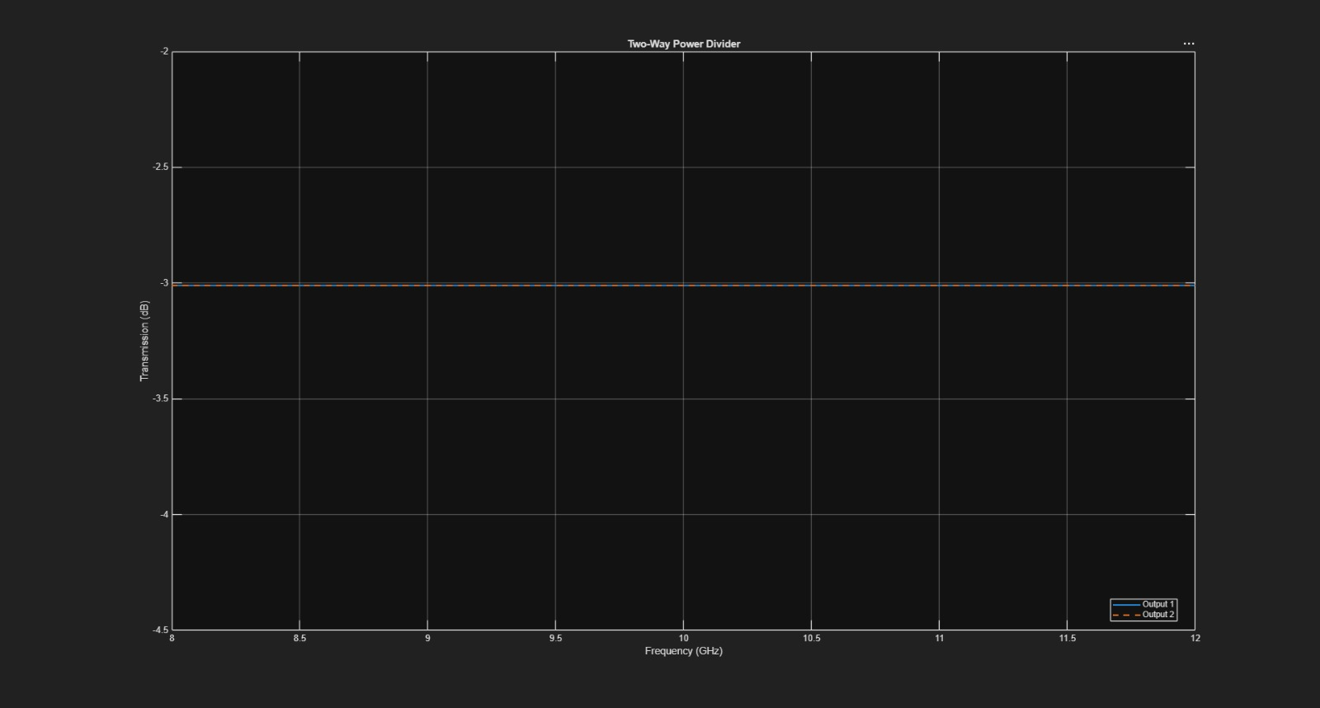
Figure 2. Two-way 3 dB power-divider response over 8–12 GHz.
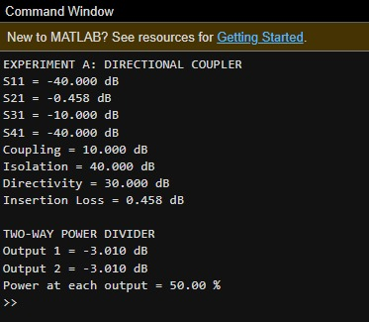
Figure 3. MATLAB command-window results for the directional coupler and power divider.

EXPERIMENT 3B — COUPLING-SECTION LENGTH OPTIMIZATION
B. Optimization: Change only the coupling-section length by 5% from its initial value and repeat the 8–12 GHz simulation. Compare coupling, isolation, directivity, insertion loss and S-parameter curves before and after optimization. Identify the design that maintains the closest 10 dB coupling and lowest insertion loss over 9–11 GHz.
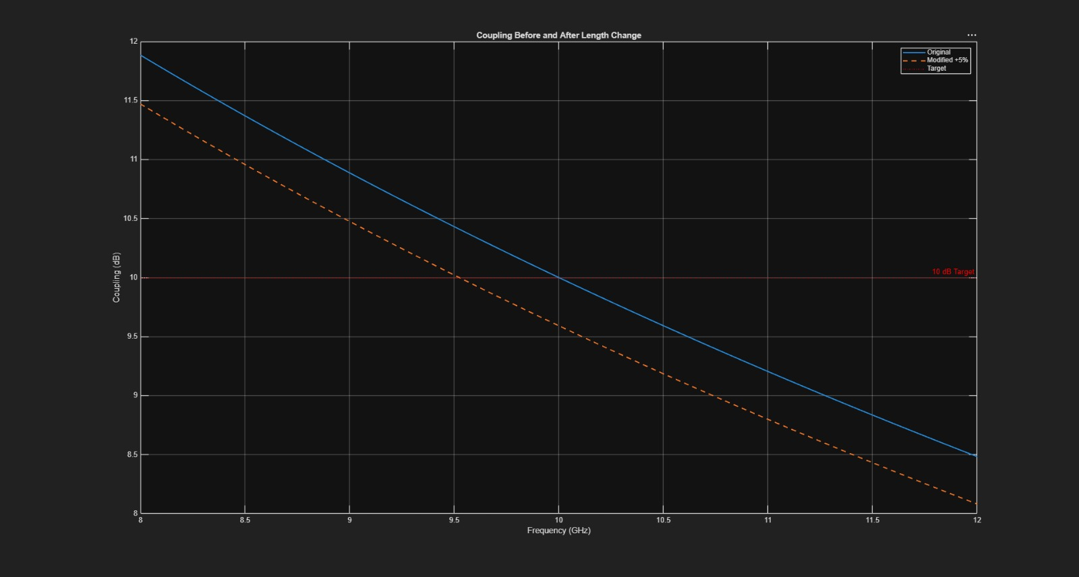
Figure 4. Coupling response before and after the 5% length change.
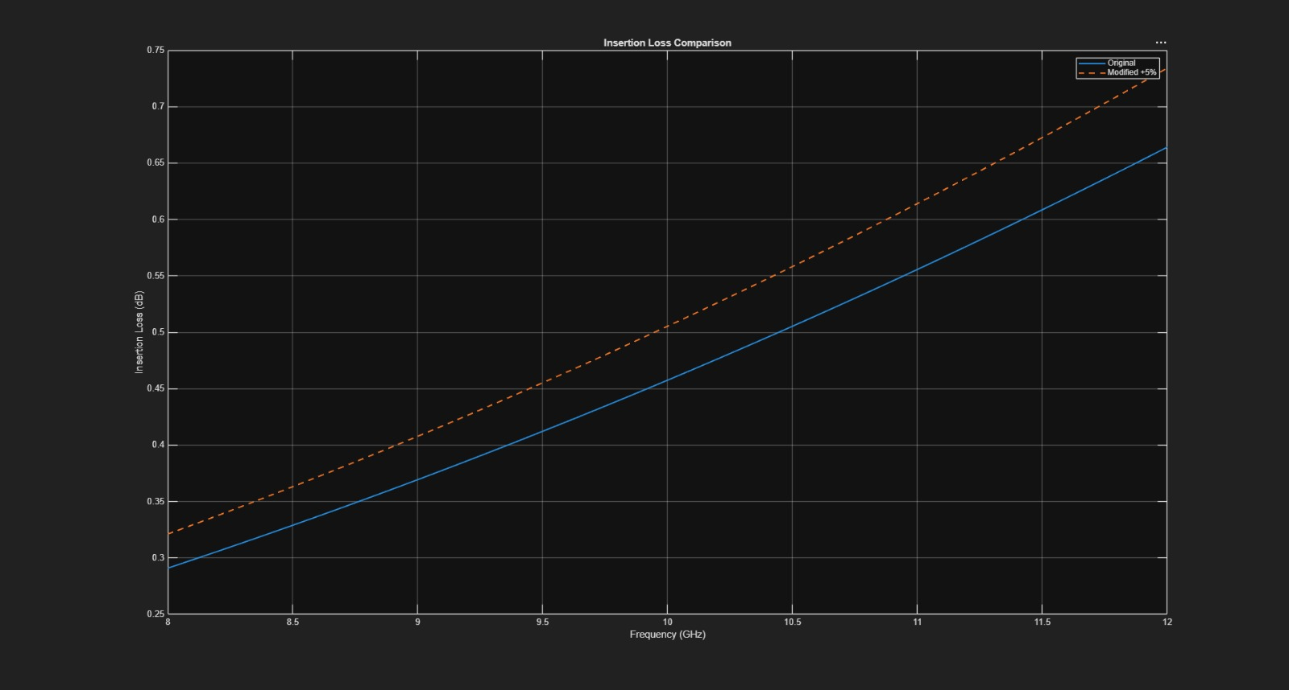
Figure 5. Insertion-loss comparison before and after optimization.
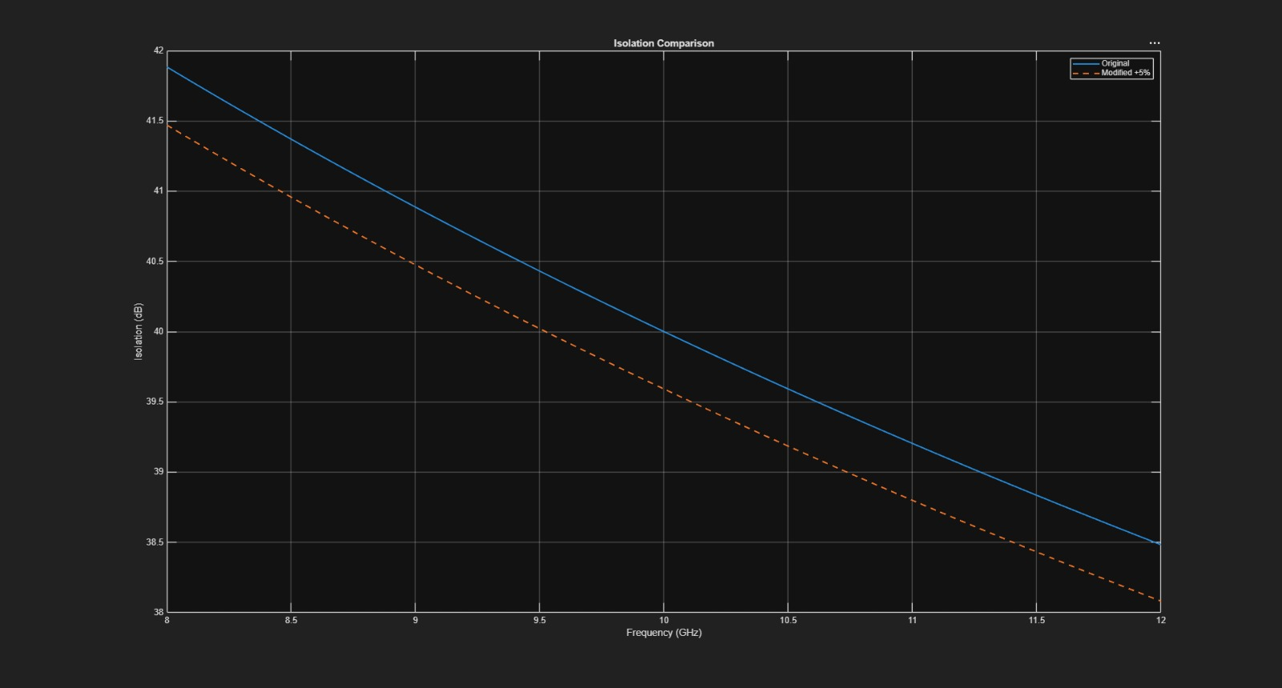
Figure 6. Isolation comparison before and after optimization.
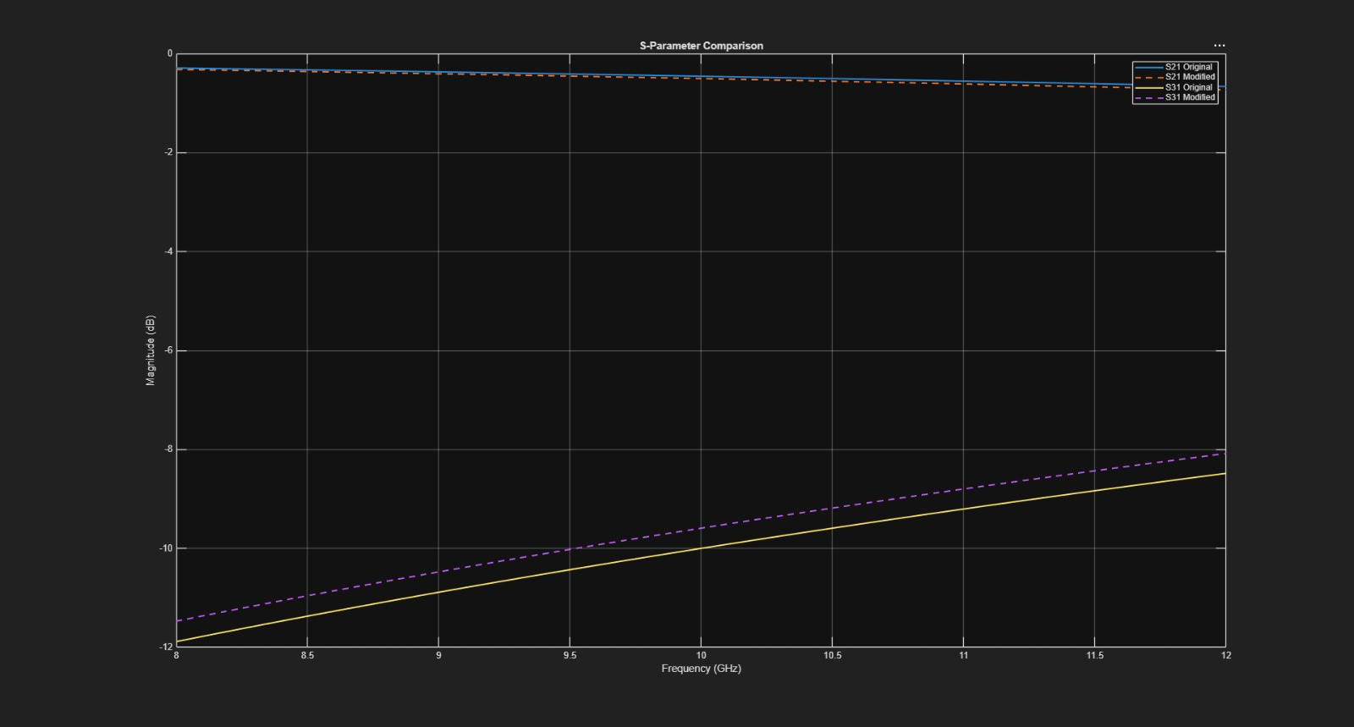
Figure 7. S-parameter comparison for the original and modified coupling-section lengths.
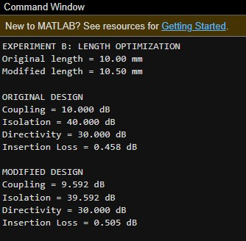
Figure 8. MATLAB command-window results for the original and modified designs.

